**Portfolio Modeling Project of Canada Pension Plan**

**Yuan Tian and Lily Luo**

**1.** **Introduction of the Institution (CPP Investments)**

In 1997, Canada Pension Plan Investment Board Act directed Canada Pension Plan Investment Board (CPP Investments) to manage the amounts transferred by the Canada Pension Plan (CPP) in the best interests of contributors to and beneficiaries of the CPP. In turn, the CPP Investment Board created the CPP Reserve Fund. It helps build a retirement foundation for 20 million Canadians. CPP Investments is independent from any government and the governance has been recognized by many international organizations.For the fiscal year ended March 31, 2020, CPP Investments has a net asset of $409.6 billion, net return of 3.1% and net income of $12.1 billion.

**2.** **Client’s objectives and constraints.**

**2.1 Investment Objectives**

CPP Investments aims to invest globally to maximize returns without undue risk of loss, with consideration of the factors that may affect funding of the CPP investment. It takes a disciplined, long-term approach to managing the Fund.

**2.2 Return Objective:**

The annualized net return of CPP investment is 9.9% for 10 years, 7.7% for 5 years, and 3.1% for the year 2020. In the past 5 years, the Bank of Canada maintained the inflation rate for 1.43% in the year 2016, 1.6% in the year 2017, 2.27% in 2018, and 1.95% in 2019. So, the real return of the CPP investment is around 7.9% for the 10 years and 5.7% for 5 years. According to the Office of the Chief Actuary of Canada, the CCP investment should maintain a real rate of return of 4%.

**2.3 Risk management objective:**

CPP investment takes both investment risks and non-investment risks into considerations, and it defines a key risk as a risk that brings a significant impact on CPP investment’s ability to pursue “a maximum rate of return, without undue risk of loss, having regard to the factors that may affect the funding of the CPP investment and the ability of the CPP investment to meet its financial obligations on any given business day” (CCP 2020 Annual Report).

**2.4** **Investment Constraints**

All the investment activities of the CPP investment are under the regulation of the Canada Pension Plan Investment Board Act and the Disclosure Policy requires the CPP investment to inform about how the money is managed. When a serious financial issue occurs, the government will support the CPP investment with the underfund difficulty.

The CPP Investment needs to maintain a long-term view and benefits from general economic growth by taking on an appropriate amount of equity risk. The CPP Investments do not screen stocks or eliminate investments based on ESG factors and can consider the securities of any issuer all of whose businesses are lawful as eligible for investment.

To manage the liquidity and leverage risk, the CPP investment monitors the use of leverage through leverage measures and through risk limits “which require sufficient liquidity to be available to manage both solvency and portfolio rebalancing risks ” .

**3. Capital Market Expectation**

We combined JP Morgan’s report “2020 Long-term Capital Market Assumptions” and an update off-cycle mark-to-market of the Long-Term Capital Market Assumptions together to summarize the expectations of different asset classes for the next 3-5 years.

**3.1 Expectations for fixed income and equities**

Long core duration assets across all major markets see poor returns in absolute terms and relative to cash, as starting yield curves are very flat. In the corporate bond market, duration has risen, and quality has deteriorated.

In contrast, JP Morgan raised equity return assumptions across most regions, with developed markets and emerging markets both up.

**3.2 COVID-19 Update**

**3.2.1 Investment Market**

Global government bond returns are down slightly since late 2019, while global equity returns are higher.

Across geographies, the returns on longer-duration bonds are worse than those for cash.

Equity returns have moved higher, driven by better starting valuations. This has implications for Sharpe ratios as well.

A rise in expected returns for private equity and real assets.

Entry points are an important driver of long-term returns, especially when markets are as volatile as they have been recently.

The recent decline in bond yields has pushed equity risk premia to near historical highs

**3.2.2 Industries**

The banking sector stands out once again, meanwhile, the giant technology and health care sectors have been relatively unscathed.

The preferred sectors include those most leveraged to consumer income (retail and restaurants. Automobile sales, responding well to low interest rates and strong demand, are up year-over-year.

**3.5 Conclusion:**

a. Fixed income investment has low return/low risk, while global equities has high return opportunities in the long run.

b. In terms of industry, healthcare, bank and giant technology sectors have been relatively unscathed.

c. Select stocks in low-priced industries (retail, restaurant and automobile) to catch up opportunities.

d. Invest some assets in private equity and real estate since there is a rise.

**4. Assets Allocation Decision**

**4.1 Security Selection**

Based on the client's objectives, constraints, and our capital market expectations, we selected 48 securities from six major sectors: healthcare, bank,technology,retail,food and fixed income. Since our client aims to “a maximum rate of return, without undue risk of loss”, we decided to allocate 15-20% assets to the fixed income sector.

And we selected stocks in each sector, we mainly focus on large companies with relatively high performance during the past five years.Then we downloaded the 5 years monthly stock prices (dividend adjusted) using their ticker symbol from Yahoo using Samir Khan’s App

**4.2 Asset Allocation**

**4.2.1 Sample Securities**

Firstly, we built up the correlation matrix for all the securities, the average correlation of all securities is 0.23. Then we identified the highest correlation pairs under each sector and eliminated one of each pair to overcome such problems. After removing, we formed our sample equities with a total number of 38 and average correlation of 0.24.

The sector distribution of our sample securities is:

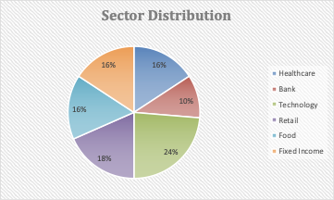

**4.2.2 Variance-Covariance Matrix**

We calculated the variance-covariance of the sample securities using 4 methods(Correlation,Single Index Model, Constant Correlation Method,Shrinkage Method) and combined the matrix with security returns.

**4.2.3 Asset Allocation**

1. Unconstrained Optimization

Through the unconstrained method, the portfolio mean return is 0.76%, sigma is 0.45% and theta is 165.69% which is pretty high. This optimization has really low risk but also low return. The asset allocation short sale 47% of our stocks. Since this result cannot meet our requirements which is to try to reach high return with acceptable risk. We tried another optimization method.

1. Constrained Optimization  
   According to our client’s objectives, there are no constraints on particular securities or sectors and also no specific constraints on short sale.

We first constraint the return of our portfolio to the 4% target and allow short sale, the result shows mean return is 4%, sigma 2.58% and theta 160.33%. The asset allocation is:

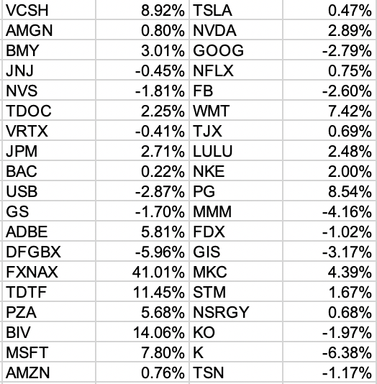

Then we do not allow short sale and also try to set our return target no less than 3%, and we ran the optimization again aimed at getting the highest theta under such constraints. The result shows our portfolio mean return is 3%, sigma is 4.96% and theta is 60.11%. In this allocation, it only takes 8 stocks, the distribution is:

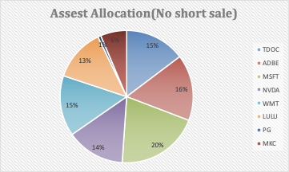

**5. Black-Litterman Modeling**

First of all, we get the market cap of the 48 stocks. However, since we’ve chosen 38 of them to be included in our final portfolio after eliminating the stocks that are highly correlated. So, we end up with using the market cap of the 38 stocks to calculate the weights of each in the benchmark.

Then, we use the Black-Litterman approach to calculate the implied returns in our 38 securities benchmark. Same shrinkage variance-covariance matrix from the variance-covariance matrix section is used as the base of the calculation. Finally, we get the monthly implied returns of the 38 securities (Annual return need to *12). Also, we calculate the optimal portfolio according to the implied return. The expected return of the benchmark meets our anticipated benchmark return as 4% per year, or 0.33% per month.

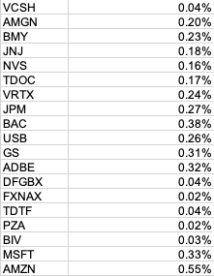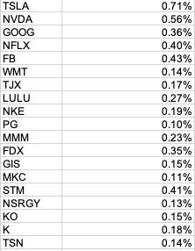

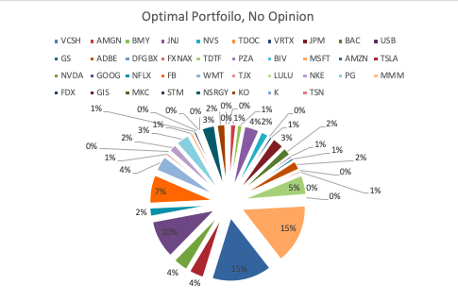

We agree with most of the returns of the stocks, but we adjusted AMGN and BMY by adding 0.05% and 0.1%. Since we are very positive about the future growth of the two companies and the field of Healthcare in general, especially during and even after the COVID-19 pandemic from our market research. Then, we calculated the adjusted monthly return according to our opinion( delta of analyst opinion) and the tracking matrix by using the Bltracking function. Then, we times adjusted monthly return to 12 to get the adjusted annual return for opinions. Lastly, we calculated the opinion-adjusted optimized portfolio according to adjusted monthly return. The final portfolio of the no opinion one and the adjusted one is not significantly different in general, since we did not adjust much. However, we can still see about 5-6% changes on the two companies of AMGN and BMY as we expected.

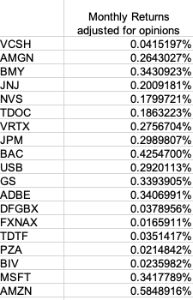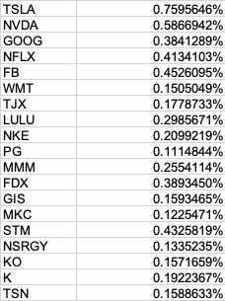

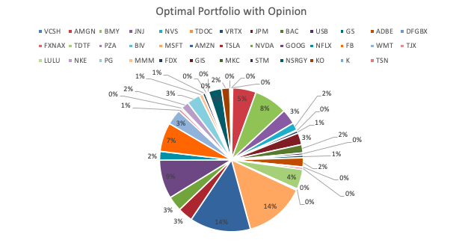

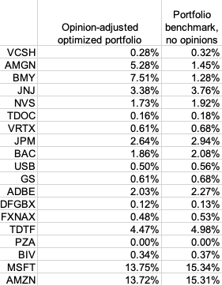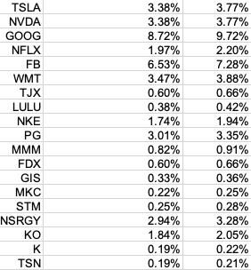

**References:**

[1] CPP Investments Annual Report, Wikipedia

[2] https://laws-lois.justice.gc.ca/eng/acts/c-8/index.html

[3] JP Morgan Global Equity Views 3Q 2020

[4] JP Morgan’s report “2020 Long-term Capital Market Assumptions”

[5] JP Morgan LTCMA Mark-to-Market: COVID-19 – New cycle, new starting point